Dependency Injection (DI)
The technology that Spring is most identified with is the Dependency Injection (DI) flavor of Inversion of Control. The Inversion of Control (IoC) is a general concept, and it can be expressed in many different ways. Dependency Injection is merely one concrete example of Inversion of Control.
When writing a complex Java application, application classes should be as independent as possible of other Java classes to increase the possibility to reuse these classes and to test them independently of other classes while unit testing. Dependency Injection helps in gluing these classes together and at the same time keeping them independent.
What is dependency injection exactly? Let's look at these two words separately. Here the dependency part translates into an association between two classes. For example, class A is dependent of class B. Now, let's look at the second part, injection. All this means is, class B will get injected into class A by the IoC.

Dependency injection can happen in the way of passing parameters to the constructor or by post-construction using setter methods. As Dependency Injection is the heart of Spring Framework

Dependency Injection is a design pattern that allows us to remove dependencies from code so that its easier to maintain and test the code.

Lets try to understand why we really need dependency injection.
Consider two classes Circle and DrawShape as given below.
class Circle{
void drawCircle(){
//some code
}
}

class DrawShape{
void draw(){
Circle obj = new Circle();
obj.drawCircle();
}
}
In this example DrawShape class is dependent on Circle class because we have used new keyword to create Circle object. In case we change name of Circle class or its constructor arguments then we have to also do changes in DrawShape class as it uses Circle class.
Assume if the Circle class is used in 100 other classes. In that case we have to do changes in 100 classes and that will require lot of time and efforts. Also we can not test DrawShape class without importing Circle class.
So it becomes difficult to manage and test the code.
To solve this problem Dependency Injection concept is used.
In Spring Framework there are two ways to inject dependency.
- Dependency Injection Using Constructor (Constructor Injection)
- Dependency Injection Using Setter Method (Setter Injection)

Spring Constructor Injection Example
Create a spring project with following files.
Shape.java
Package com.spring;

Public interface Shape{
Public void draw();
}
Circle.java
Package com.spring;

public class Circle implements Shape{

@Override
Public void draw(){
System.out.println("Drawing Circle....");
}

}
DrawShape.java
Package com.spring;

Public class DrawShape{
Shape shape;

DrawShape(Shape shape){
this.shape=shape;
}

Public void drawShape(){
shape.draw();
}
}
TestClass.java
Package com.spring;

Import org.springframework.context.ApplicationContext;
Import org.springframework.context.support.ClassPathXmlApplicationContext;

Public class TestClass{

public static void main(String[]args){
ApplicationContext context = new ClassPathXmlApplicationContext("configuration.xml");

DrawShape obj=(DrawShape) context.getBean("drawShapeBean");
obj.drawShape();
}
}

configuration.xml
<beans xmlns="http://www.springframework.org/schema/beans"
xmlns:xsi="http://www.w3.org/2001/XMLSchema-instance"
xsi:schemaLocation="http://www.springframework.org/schema/beans
http://www.springframework.org/schema/beans/spring-beans.xsd">

<bean id="drawShapeBean"class="com.spring.DrawShape">
<constructor-arg ref="circleBean"/>
</bean>

<bean id="circleBean"class="com.spring.Circle"></bean>
</beans>
In above code <constructor-arg> tag, it is used to inject Circle class object in DrawShape constructor at runtime.
Output
When you will run the project it will show following output in ide console.
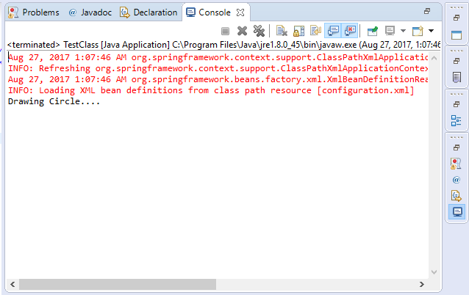

Spring Setter Method Injection Example
We simply replace constructor with setter method setShape() in DrawShape class.
Package com.spring;

public class DrawShape{
Shape shape;

Public void setShape(Shape shape){
this.shape=shape;
}

Public void drawShape(){
shape.draw();
}
}
Also replace <constructor-arg> tag with <property> tag in configuration.xml file.
<beans xmlns="http://www.springframework.org/schema/beans"
xmlns:xsi="http://www.w3.org/2001/XMLSchema-instance"
xsi:schemaLocation="http://www.springframework.org/schema/beans
http://www.springframework.org/schema/beans/spring-beans.xsd">

<bean id="drawShapeBean "class="com.spring.DrawShape">
<propertyname="shape" ref="circleBean"/>
</bean>

<bean id="circleBean" class="com.spring.Circle"></bean>
</beans>
The <property> tag inject the Circle object in setter method of DrawShape class at runtime.
All other code will be same as used in construction injection example.

Dependency Injection by Constructor Example
- Dependency Injection by constructor
- Injecting primitive and string-based values
We can inject the dependency by constructor. The <constructor-arg> subelement of <bean> is used for constructor injection. Here we are going to inject
- primitive and String-based values
- Dependent object (contained object)
- Collection values etc.
Program 3: A BankAccount Application – Constructor Injection Primitive Values

Component | Code
Account.java | package bnk.p1;  public class Account {  int acNo;  String acName;  double acbalance;  public int getAcNo() {  return acNo;  }  public void setAcNo(int acNo) {  this.acNo = acNo;  }  public String getAcName() {  return acName;  }  public void setAcName(String acName) {  this.acName = acName;  }  public double getAcbalance() {  return acbalance;  }  public void setAcbalance(double acbalance) {  this.acbalance = acbalance;  }  public Account(int acNo, String acName, double acbalance) {  super();  this.acNo = acNo;  this.acName = acName;  this.acbalance = acbalance;  }  public Account() {  super();  }  }
Appctx.xml | <?xml version="1.0" encoding="UTF-8"?>  <beans xmlns="http://www.springframework.org/schema/beans"  xmlns:xsi="http://www.w3.org/2001/XMLSchema-instance"  xsi:schemaLocation="http://www.springframework.org/schema/beans http://www.springframework.org/schema/beans/spring-beans.xsd">  <bean id="Account" class="bnk.p1.Account">  <constructor-arg index="0" value="1">  </constructor-arg>  <constructor-arg type="String" value="om">  </constructor-arg>  <constructor-arg value="2300"></constructor-arg>  </bean>  </beans>
AccountTest.java | This class gets the bean from the applicationContext.xml file and calls the show method.  package bnk.p1;  import org.springframework.context.support.ClassPathXmlApplicationContext;  import org.springframework.context.ApplicationContext;  public class AccountTest {  public static void main(String[] args) {  ApplicationContext ctx=new ClassPathXmlApplicationContext("appctx.xml");  Account a1=(Account) ctx.getBean("Account");  System.out.println("Ac NO:"+a1.getAcNo());  System.out.println("Ac Name:"+a1.getAcName());  System.out.println("Ac Balance:"+a1.getAcbalance());  }  }
Program 4: Employee Application – Constructor Injection Reference Types
Component | Code
Employee.java | package me.emp;  public class Employee {  int id;  FullName name;  public Employee(int id, FullName name) {  super();  this.id = id;  this.name = name;  }  void show(){  System.out.println("Id:"+id);  System.out.println("Full Name:"+name);  }  }
FullName.Java | package me.emp;  public class FullName {  private String Fname;  private String Mname;  private String Lname;  public FullName(String fname, String mname, String lname) {  super();  Fname = fname;  Mname = mname;  Lname = lname;  }  public String toString(){  return Fname+" "+Mname+" "+Lname;  }  }
Appctx.xml | <?xml version="1.0" encoding="UTF-8"?>  <beans xmlns="http://www.springframework.org/schema/beans"  xmlns:xsi="http://www.w3.org/2001/XMLSchema-instance"  xsi:schemaLocation="http://www.springframework.org/schema/beans http://www.springframework.org/schema/beans/spring-beans.xsd">  <bean id="FullName" class="me.emp.FullName">  <constructor-arg value="Omprakash"></constructor-arg>  <constructor-arg value="Laxman"></constructor-arg>  <constructor-arg value="Mandge"></constructor-arg>  </bean>  <bean id="Employee" class="me.emp.Employee">  <constructor-arg value="1"></constructor-arg>  <constructor-arg>  <ref bean="FullName"/>  </constructor-arg>  </bean>  </beans>
EmpTest.java | package me.emp;  import org.springframework.context.ApplicationContext;  import org.springframework.context.support.ClassPathXmlApplicationContext;  public class EmpTest {  private static ApplicationContext appCon;  public static void main(String[] args)  {  appCon = new ClassPathXmlApplicationContext("appctx.xml");  Employee factory=(Employee)appCon.getBean("Employee");  factory.show();  }  }
Program 5: Shape Application – Setter Injection
Component | Code
Shape.java | package me.org;  public interface Shape {  void show();  }
Circle.java | package me.org;  public class Circle implements Shape {  public void show()  {  System.out.println("I am Circle");  }  }
ShapeMAnager.java | package me.org;  public class ShapeManager {  Shape myShape;  public void show()  {  this.myShape.show();  }  public Shape getMyShape() {  return myShape;  }  public void setMyShape(Shape myShape) {  this.myShape = myShape;  }  }
ShapeTest.java | package me.org;  import org.springframework.context.ApplicationContext;  import org.springframework.context.support.ClassPathXmlApplicationContext;  public class ShapeTest {  private static ApplicationContext appCon;  public static void main(String[] args)  {  appCon = new ClassPathXmlApplicationContext("appctx.xml");  ShapeManager factory=(ShapeManager)appCon.getBean("ShapeMan");  factory.show();  }  }
Appctx.xml | <?xml version="1.0" encoding="UTF-8"?>  <beans xmlns="http://www.springframework.org/schema/beans"  xmlns:xsi="http://www.w3.org/2001/XMLSchema-instance"  xsi:schemaLocation="http://www.springframework.org/schema/beans http://www.springframework.org/schema/beans/spring-beans.xsd">  <bean id="Circle" class="me.org.Circle"></bean>  <bean id="ShapeMan" class="me.org.ShapeManager">  <property name="myShape" ref="Circle"></property>  </bean>  </beans>
Program 6: MovieApplication – Injection using Collection

Component | Code
Movie.java | package me.org;  import java.util.*;  public class Movie {  private List<String> movies;  public List<String> getMovies() {  return movies;  }  public void setMovies(List<String> movies) {  this.movies = movies;  }  public void printMovies(){  System.out.println(this.movies);  }  }
Appctx.xml | <?xml version="1.0" encoding="UTF-8"?>  <beans xmlns="http://www.springframework.org/schema/beans"  xmlns:xsi="http://www.w3.org/2001/XMLSchema-instance"  xsi:schemaLocation="http://www.springframework.org/schema/beans http://www.springframework.org/schema/beans/spring-beans.xsd">  <bean id="Movie" class="me.org.Movie">  <property name="movies">  <list>  <value>A Beautiful Mind</value>  <value>Inception</value>  <value>Cast Away</value>  </list>  </property>  </bean>  </beans>
MovieTest.java | package me.org;  import org.springframework.context.ApplicationContext;  import org.springframework.context.support.ClassPathXmlApplicationContext;  public class MovieTest {  private static ApplicationContext appCon;  public static void main(String[] args)  {  appCon = new ClassPathXmlApplicationContext("appctx.xml");  Movie factory=(Movie)appCon.getBean("Movie");  factory.printMovies();  }  }

Spring Bean Scopes

Following are various kinds of bean scopes which are available in Spring framework.

Spring Bean Definition

Beans are objects which creates the backend of your any java enterprise application. Beans are maintained by Spring IoC container. Any bean is a simple object of bean class which is instantiated, configured and also maintained by Spring IoC container. These beans have some unique configuration metadata which developers supply to Spring IOC container.
Developers provide Bean definition which contains configuration information which is known by configuration metadata, that is necessity for application’s Spring IOC container to know these following:
- How to make a bean
- Bean’s lifecycle and scope
- Bean’s dependencies

Spring Bean Scopes
Bean Scope defines how many the bean instances will be created and returned by spring IOC container. In the spring bean configurations, developers define bean attribute called ‘scope’ .
In Spring, there are 5 different kinds of scopes.
- Singleton Scope
- Prototype Scope
- Request Scope
- Session Scope
- GlobalSession Scope
There are 3 scopes mentioned by request scope, session scope and globalSession scope are only used in a web-aware kind of applications.
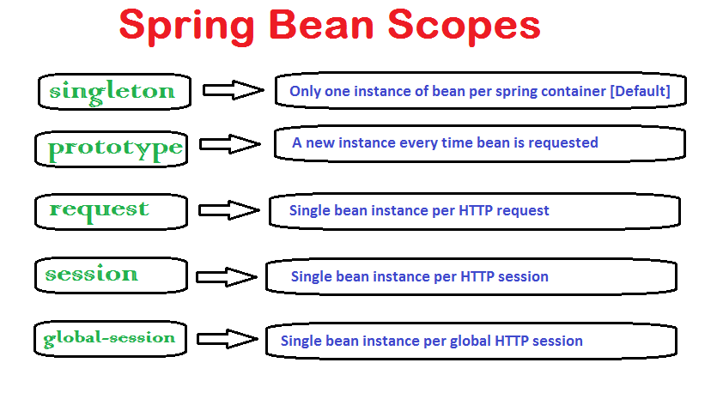

How to Define the Bean Scope?
This can be done in two ways.
1. In bean configuration file
<beans xmlns="http://www.springframework.org/schema/beans"
xmlns:xsi="http://www.w3.org/2001/XMLSchema-instance"
xsi:schemaLocation="http://www.springframework.org/schema/beans
http://www.springframework.org/schema/beans/spring-beans-2.5.xsd">

<bean id="meBean"class="com.shubham.MeBean" scope="SCOPENAME"/>

</beans>
2. Using annotations
@Service
@Scope("SCOPENAME")
Public class MeBean
{
//My code
}
Scope 1: Singleton Scope
<!-- Abean definition with singleton scope-->

<bean id="yourbeanid"class="yourbeanclass"scope="singleton">

<!-- collaborators andconfiguration forthisbean go here-->

</bean>
When we define our bean by mentioning singleton scope then it means that the Spring IOC container will creates only a single object of our bean, and all client coming requests for that bean class will send that same object of that bean towards user interface.
Any rectifications to that specific object will also be mirrored in all available instances to that particular bean. Singleton scope is the default value for scope if no other scope is defined in bean configuration. Singleton bean scope is default and it enforces the Spring IOC container to have only one object for every spring container, that is independent of how much time you request for its object. This singleton behavior is maintained by bean factory itself.

Scope 2: Prototype Scope
When the prototype scope is given then the Spring IoC container makes a new bean object of the bean each time request for that particular bean is made. As a rule, use the prototype scope for all state-full beans and the singleton scope for stateless beans.
We can define prototype scope as described in the below code example.
<!--Abean definition with singleton scope-->

<bean id=" yourbeanid "class=" yourbeanid "scope="prototype">

<!--collaborators andconfiguration forthisbean go here-->

</bean>

Web Aware Scopes
For the web-aware kind of application, there are 3 more scopes available. These are not used in general prectice.
Request scope makes a bean object for every HTTP request comes from client. Session scope makes an bean object for that HTTP Session, the globalSession scope makes an object of the bean for that global HTTP Session.

Scope 3: Request Scope
For defining the bean by request scope we have to use same @Scope annotation with value of SCOPE_REQUEST:
@Scope(value=WebAppContext.SCOPE_REQUEST,proxyMode=ScopedProxyMode.TARGET_CLASS)

publicMyServiceMyRequestMessage(){
returnnewMyService();
}
With these kind of bean scope, new bean object will then made for every web request invoked by the client. When request gets completed, bean will not be having that scope.

Scope 4: Session Scope
For defining the bean with session scope, we have to use same @Scope annotation with value of SCOPE_SESSION:
@Bean
@Scope(value=WebAppContext.SCOPE_SESSION,proxyMode=ScopedProxyMode.TARGET_CLASS)

publicMyServiceMySessionMesage(){
returnnewMyService();
}
Just as request scope, session scope ensures only one object of that bean for every session of the user. When user’s session is ended, bean will not be having that scope.

Scope 5: Global Session Scope
we define the globalSession scope with providing value of SCOPE_GLOBAL_SESSION, in annotation @Scope.
@Bean
@Scope(value=WebAppContext.SCOPE_GLOBAL_SESSION,proxyMode=ScopedProxyMode.TARGET_ CLASS)

publicMyServiceMyGlobalMessage(){
returnnewMyService();
}
These kind of scope is generally applied in the applications with specific portlet container, and each and every portlet is associated by its unique session. Beans by Global Session scope will always be present over all the sessions instantiated by user.
global-session is always associated with Portlet kind of applications. When we define our application to handle requests in the Portlet container then it is made upon some number of portlets. Every portlet contains its unique session, and if we wanted for our application to keep variables globally for all the portlets in our web application than we should keep them in the global-session. Global-session scope does not have any kind of special effect different then session scope defined in spring based applications.
Note: You can also define above scopes in bean configuration file.

Spring Bean Life Cycle
Spring bean life cycle. It is root of Spring framework or to get into any IT company or to make any product in proper way in Spring.
Definition:
The sequence of changes which occurs in the spring bean is called spring bean life cycle from its initialization to its destruction. Spring life cycle tells us about how Spring bean will be maintained by Spring IOC Container.
Methods for it:
It is really easy to understand about Spring bean life cycle. When Spring IOC container invoke the bean object, then it is needed to do some initialization steps to establish usable stage. When that initialized bean is not usable then it is removed by spring IOC container. There are a lot of different processes among invocation and removal of that spring bean object. These processes take place in the backend. These are following stages in life cycle of any Spring bean.
- Objectification – Spring IOC container instantiate that specified bean.
- Injection of Bean’s Properties – Spring IoC container injects the bean’s properties.
- Setting of Bean Name – In this process Spring IOC container puts that specified bean name.
- Setting of Bean Factory – In this process Spring IOC container calls method setBeanFactory().
- Calling of Pre Initialization – Pre initialization of bean is also known by name of postprocess of bean. In this Spring IOC container calls method named postProcesserBeforeInitialization().
- Calling of Initialize Beans – When that specified bean implements interface IntializingBean, then Spring IOC container calls method named afterPropertySet(). When that spring bean has declaration of init method then that provided method is called by Spring IOC named initialization.
- Calling of Post Initialization – In this process Spring IOC container calls method postProcessAfterinitalization().
- Bean is Settled for usage – Now we have spring bean object which we can use for our application processes.
- Removal of that Bean – In this process Spring IOC container calls method destroy() of interface DisposableBean.
